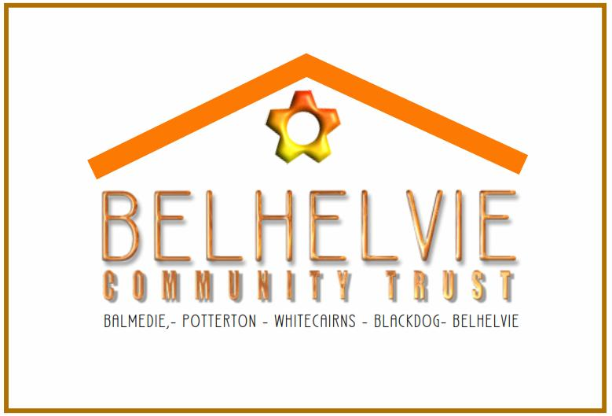

Belhelvie Community Trust -
Membership Application

You are invited to become a member of the Belhelvie Community Trust.

Applicants must be over the age of 16. Membership is open to those who are resident or actively involved in the Belhelvie Community. Membership involves helping to elect a Management Committee of up to 10 people, reviewing the work of the Trust and attending the Annual General Meeting. Thereafter you can be as active in the work and projects of the Trust as you wish.
For more information:www.belhelviecommunitytrust.wordpress.com

* I wish to become an Ordinary Member 0

* I wish to become an Associate Member 0

I consent to my personal details being kept by the Trust, and understand that the Trust will not pass these to a third party unless it seeks my specific permission.

Name / Signature
Address / Postcode
Telephone / Email

* Ordinary Membership is available to anyone who lives in Belhelvie Parish

* Associate Membership is available to anyone who lives outside Belhelvie Parish who wishes to support the work of the Trust

please return to 8 Oldmill Crescent Balmedie AB23 8WA

